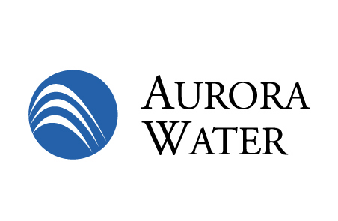

**Stormwater Operations**

**Sediment Management Plan**

**2010**



**Acknowledgements:**

Urban Drainage and Flood Control District

City of Aurora Public Works

Aurora Water / Stormwater

**Executive Summary**

The Stormwater Division of the Aurora Water Department is responsible for the maintenance of approximately 75 miles of drainage channels throughout the City of Aurora. Maintenance of these channels includes trash/debris and sediment removal. Storm channel aggradation, a condition where the level of a stream bed is raised or filled by deposition from sediment, is an ongoing channel characteristic and must be managed. Sedimentation that is not managed effectively has the potential to compromise the overall function of the conveyance system and the water quality features of the channel.

Regulators at the Federal, State and Local level require that Stormwater Management Plans / Programs be developed and implemented in order to maintain regulatory compliance. These regulatory requirements and subsequent Stormwater management plans create a situation where multiple objectives for managing flood risk and environmental impact risks are realized. These multiple objectives are a result of Federal Emergency Management Agency (FEMA) maintenance activity guidance; Federal wetlands 404 permit guidance and the stormwater quality requirements of the Clean Water Act.

In an effort to meet these multiple objectives a comprehensive and systematic sediment management program is critical to develop and implement. This plan is intended to consider drainage functionality, environmental stewardship, and fiscal resource management while managing risk and maintaining regulatory compliance.

**Objective**

The objective of this plan is to develop a comprehensive and systematic sediment management decision tool, while not absolute, that will assist key decision makers in sediment management strategies for operational maintenance response.

**Regulatory Requirements**

The City of Aurora is a participating Community in the National Flood Insurance Program (NFIP) which is administered by FEMA. The NFIP offers reasonably priced flood insurance to communities that comply with minimum standards for floodplain management. The NFIP also manages the Community Rating System (CRS). The NFIP/CRS recognizes community efforts beyond those minimum standards by reducing flood insurance premiums for community property owners. The City of Aurora is currently a participating community and in good standing in the CRS program. As of 2008 there are 238 homeowners in Aurora who are required to have flood insurance with annual premiums of $168,529 dollars. The City’s current maintenance program, recognized through the CRS program, provides for a 10% discount for policy owners, or $14,625 dollars in savings on an annual basis.

The Environmental Protection Agency (EPA) also mandates a permit program that is administered by State agency and implemented through local municipalities. This permit is a State of Colorado Discharge Permit issued through the Colorado Department of Public Health and Environment (CDPHE). This permit requires the permittee to operate a stormwater management program. One of the elements of the program requires the permittee to maintain a program of routine maintenance activities to reduce pollutants. Pollutants like sediment, trash / debris are required to be periodically removed from municipally-owned detention facilities and open-channel drainage ways. By engaging in on-going efforts to reduce pollutants, water quality can be maintained for beneficial use for both downstream and in stream use for aquatic and riparian life. In areas of new development for example, source controls, like forebays in water quality ponds, are now required that eliminate or reduce the excess sediment load to downstream receiving streams. However, it is generally not practicable to retrofit stormwater quality controls into drainage facilities of existing development. Hence, a managed approach to preventing or controlling sediment accumulation helps Aurora meet regulatory objectives pertaining to both flood control and water quality.

**Design Criteria**

The City of Aurora Storm Drainage Design Criteria and Urban Storm Drainage Criteria Manual require that open channels in a typical stormwater conveyance system be designed to meet a level of service or a design frequency. This level of service or design frequency standard is referred to as the 100-year flood level. This design requirement includes a minimum one foot free board as a safety factor. Free board is the margin of safety added to the base flood elevation to account for any change of conditions over time and to incorporate inherent inaccuracies of hydrologic calculations. However, this free board is not designed specifically to allow for sediment accumulation and storage but rather a general safety factor for changes that occur in channel roughness due to vegetation, debris in channel, partial clogging of crossing structures etc. This free board safety factor provides operational flexibility so that significant maintenance is not required on an annual basis.

**Managing Risk**

The starting point for defining acceptable risk is established as the 100-year flood conveyance. It is difficult to quantify the increased level of risk that may be incurred due to channel aggradation as a function of sediment management. However, reduced storm conveyance due to aggradation is not a linear relationship with the recurrence period. For example, the peak flow for a 50-year event is not ½ the peak flow of the 100-year event. In fact the 50-year peak flow is often in the range of 80% to 90% of the100-year flow. This varies with every drainage basin being considered but the general relationship holds true.

Applying this relationship to an example of a 20% loss of channel conveyance due to channel aggradation does not merely increase the 100-year event to the 80-year event (20% reduction). It is more dramatic than that. A loss of 20% of conveyance reduces the recurrence period that can be handled from the 100-year event to something significantly less. (20 - 40 year range). That is a dramatic reduction in protection, or increased risk that is incurred. The graph below provided by Urban Drainage and Flood Control District (UDFCD) shows the relationship between peak flows in cubic feet per second (cfs) and the recurrence period (year return period. (20 – 100 year event) on a hypothetical stream.

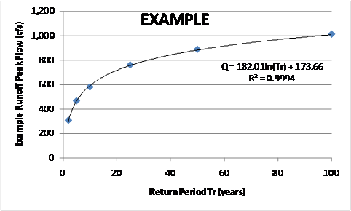

Managing risk is a challenging task when you factor in the dynamics of drainage characteristics while working to maintain a multi-objective plan that protects life and property while considering environmental stewardship and maintaining regulatory compliance. This is why a sediment management plan is critical to develop and implement.

**Maintenance Intervals**

Determining maintenance intervals for the periodic removal of sediments must be balanced with the designed service level and service expectation in mind. As an example, cleaning sediment from channels too frequently has the potential to disrupt the protective vegetation that exists to protect the channel from excessive erosion. In this case the protective vegetation must be considered as part of the overall asset and one of multiple objectives that stormwater management planning must consider and incorporate.

Managing designed service levels and service expectation also must consider fiscal stewardship of public resources. The fact that the City of Aurora has less flood damage insurance claims than any other major City in Colorado speaks to a balanced approach to maintenance intervals that are currently utilized within Aurora.

**Operations and Maintenance (O&M)**

An effective O&M plan for sediment management is key to maintaining a balanced approach to maintenance. Key elements that contribute to an effective sediment management plan include: annual inspection of all drainage ways, annual monitoring through photographic documentation, training of employees to insure consistency of maintenance decisions, measuring aggradation utilizing key conveyance system benchmarks like: partially blocked outfalls or excessive accumulation on structures, and finally a prioritization process that considers the aggradation trigger points, risk assessment, service expectation and service levels.

The development of O&M plans based on these key elements should then be applied to specific channel reaches and / or segments. Based on industry best management practices sediment removal and channel restoration, to designed capacity, should be considered once the aggradation exceeds one foot for channelized or “improved” drainage way reaches.

Typical O&M plans to include:

1. Channel prioritization for inspections
2. Channel inspection
3. Risk assessment and evaluation
4. Aggradation evaluated and prioritized
5. Aggradation quantified by PW survey
6. Annual prioritized list of sediment mitigation projects

**Conclusion**

The Stormwater Division of the Aurora Water Department is responsible for the O&M of all drainage conveyance throughout the City of Aurora. Many regulatory agencies like, FEMA / EPA, require that participating communities comply with minimum standards for floodplain management. Compliance with these standards assures that multiple objectives for managing flood risk and environmental impacts are realized. This sediment management plan is intended to be a decision making tool to assist key decision makers in sediment management strategies for operational optimization. This plan considers drainage functionality, environmental stewardship, and fiscal resource management while managing risk and maintaining regulatory compliance.